The table and charts below give information on the police budget for 2017 and 2018 in one area of Britain. The table shows where the money came from and the charts show how it was distributed.
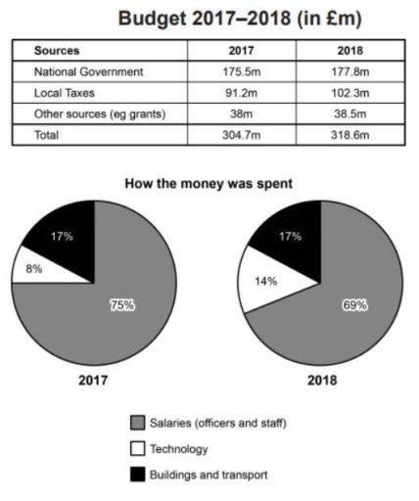
The provided table and charts illustrate statistical insight related to the police budget on a specific area in Britain in 2017 and 2018.
Overall, it is evident that the National government was the leading primary source of police budget while, grants and other sources contributed bottom-most position in police allotted budget. In contrary, money spent on salaries by the fraction of ¾%, meanwhile Technology consumes about less than 1/3% of money over the year.
A detailed observation indicates that the money came from National Government, Local Taxis, and Grants to function the police department. Subsequently, National administration body arranged 175.5 million in 2017 and this increase slightly by the next year and climbed at 177.8 million. However, Local Taxes those are given by the local public have significant contribution in budget collection, 91.2 million collected in 2017 and this increased about 10 million by the upcoming year. Moreover, Grants positioned on the bottom-most but still have non-negligible existence in budget.
The charts give information about expenditure, a large segment of money spent on salaries, this trend had a decline from 75% to 69% over the year. Furthermore, Technology had a dramatic increase from 8% to 14%. Nonetheless, the building and transportation remain steady on 17%.

